**Cougar Pizza Database Design Package**

**IT – 235**

**Michael Johnson**

**Purpose, goals, and objectives**

The purpose of the database for the Morgan’s pizza delivery service is to aid in validating that the business is performing well and to help support the business needs. The database should hold records of the customers and information pertaining to their orders. It should be able to calculate sales to help determine if the business is staying profitable and should be easy to understand and update as needed.

**User requirements**

The database should be able to perform numerous actions and provide information in many areas for the user. These areas include:

* Track all pizza orders including toppings added, pizza type, amount of pizzas ordered. This will allow for tracking popular pizza orders and help with ordering.
* Track customer information such as name, address, phone number, zip code, city, and state. This will make it easier to pull up return customer information.
* Track delivery information such as who took the order, the delivery driver name, and delivery driver phone number. This information can be used to see if employees are performing as expected and to follow up on any potential issues in the order taking process.
* Track delivery status throughout the night including order date and time and delivery date and time. This information can be utilized to provide information on issues with slow deliveries or underperforming staff.
* Track critical sales information for various timeframes. This will allow for financial review of the company and allow for future planning.
* Unique store ID numbers. This will be beneficial if/when the company decides to expand. This will allow orders and employees to be easily tracked at the respective store.
* Display pricing information for pizzas and extra toppings to allow for easy order taking.
* Separate area for making/displaying customer notes. This will track any special instructions for the employees.

**Business processes and restrictions**

Many business rules will come into play in the designing of the database. These include:

* Each customer can order multiple pizzas, but each pizza can only belong to one customer.
* Each customer can order from multiple stores and each store can have multiple customers.
* Each pizza can have multiple toppings, and each topping can go on multiple pizzas.
* Each order take can take multiple orders, but each order can only have one order taker.
* Each order can have one delivery driver, but each delivery driver can deliver multiple orders.
* Each order can have one status and each status belongs to one order.
* Each customer can have one preferred address and each address can belong to multiple customers.
* Deliveries need to be delivered within one hour
* Each customer can have a temporary address to deliver to.

**The end result**

The result of the pizzeria database design should be efficient and contain little to no faults. It should have notable relationships that connect each entity and be easily understood. The database design should allow for quick and painless additions as the company grows in volume and decides to open new locations. End users should be able to quickly access the information needed to complete their jobs and provide the information needed. The design should allow for tracking of orders from the point the order was taken to the time it was delivered. The design should also allow for record keeping of customer information and notes for special instructions that the customer may have that is pulled up when the customers information is accessed. Ultimately, the database should contain all information the business needs to run efficiently and adhere to all business rules and constraints as dictated by the business and the stakeholders/owners.

**Conceptual Design**

Looking at the scenario and business rules, a few entities became immediately noticeable. First, a customer entity would be needed to store information such as the customer’s name, address, and phone number in case they needed to be called by the business or delivery driver. We also need a unique way to track each customer, so we will use a customer ID for this. Second, we need somewhere to store Employee information for the employees who work at Cougar Pizza and are taking the orders. For this, I created the employee entity which tracks the employee’s name, phone number, and hire date for review tracking. For the employee entity I will use an employee ID to keep track of each employee. When a customer places an order, we need somewhere to keep track of the details of the order. The order entity has a unique order ID to keep track of each order and store the information for sales purposes. The orders entity contains the customer ID and employee ID as foreign keys to help associate who the order goes to and which employee took the order. Since the owner would like to track when the order gets delivered, the order entity also contains the date the order was taken, the time it was taken, and when the order was either delivered or picked up, depending on which option the customer chose when ordering. Leading off of the orders entity, the delivery entity table tracks which delivery option the customer chose with a unique status ID. The delivery description is applied to each unique status ID and the order ID is included as the foreign key to associate a status to each order. Now, each customer is calling to order pizzas, so we have the pizza table to track the pizzas that are being added to the orders. The pizza table contains the Pizza ID for each unique pizza, the order ID to associate the pizza to the correct order, and the price of the pizza to total the customer’s order and track sales. The toppings table was added as a way to track extra toppings that the customer would like to add to each pizza. The table includes the unique topping ID along with the name of the topping and the cost of the additional topping. Since each topping can go on many pizzas, and each pizza can contain many toppings, I have added the pizza creation bridge table to change these into two one to many relationship tables. The table simply includes the primary keys from the pizza and toppings tables respectively.



**Draft ERD**



**Dependency Diagrams**

**Design Finalization**

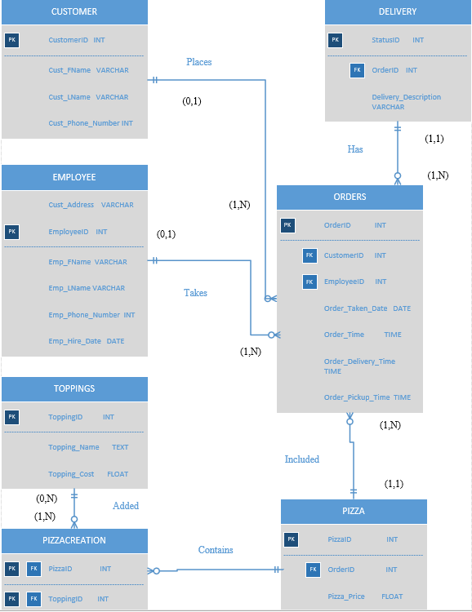

**Process**

The process used in the design of the Cougar Pizza database was to approach the design with all the business processes and rules well defined and laid out. With the business rules and processes well defined, I laid everything out and started defining entities based on the needed information for the database and what the main categories would be for that information. While defining entities that fit the business rules and the end user goals, I started grouping attributes into the entities based on their purpose using keywords from the business rules. The process was to group entities and attributes together in a way that made sense and logically flowed with the business rules. After I had everything grouped together, I started defining primary and foreign keys that helped link the tables together where needed. Once this was done, I drew the relationships between the tables, this resulted in the creation of a bridge table for two of my entities. After the draft ERD was completed, I worked through the normalization process with each table to ensure each table was in the correct normal form (3NF). Once completed and I was comfortable that each table properly represented the needed information and relationships I added the data sets and finalized the ERD.

**Achieving the end result**

The database will track all needed information for employee’s and owners (the end users) to properly run the business. Employee information will be tracked, and each order will contain an employee ID along with a customer ID to ensure the order reaches the correct customer and to track the employee in charge of the order in case of any issues. The customer table also contains the customers address and phone number to track where pizza was delivered to. Each delivery will have a status associated with it, including delivery or pickup time which is dependent on the customers chosen option at the time the order is placed. This will also show the time the order was taken. The pizza table in conjunction with the toppings table will track how many pizzas are being sold, and with what toppings. These tables will permit the ability to gather sales data for the business.